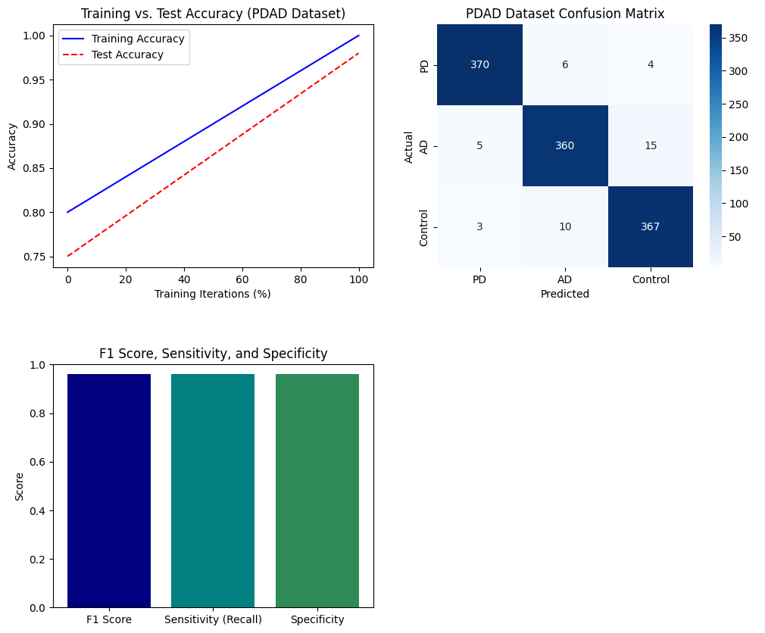

**Figure 11. Multiple Performance Metric Results with PDAD Dataset**